### **User Manuals**

### **1.1. User Login**

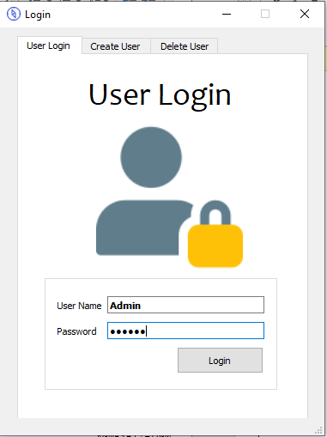

* First if your admin or you have user account enter your username and password to go next window.
* If your login success Information massage will pop up as "Login successful".

### **1.2. Create user**

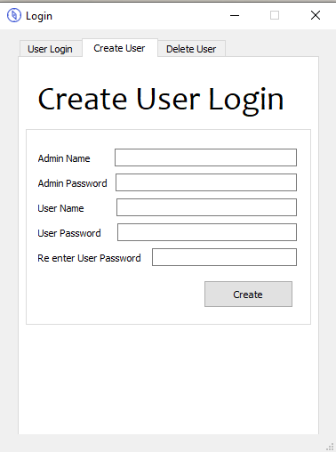

* Only admin can create new account for new user, first admin needs to enter admin name and admin password.
* Then enter new user name and enter new user password, again enter password for password. Conformation.
* Then press Create button, if new user create Information massage will pop up saying "Create account successfully".
* If you enter wrong admin data Warning massage will pop up saying "Admin data are not match !!!".

### **1.3. Delete user**

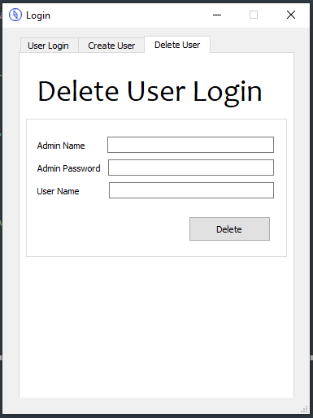

* Only admin can delete accounts, first admin needs to enter admin name and admin password.
* Then enter user name you need to delete.
* Then press Delete button, if user delete Information massage will pop up saying "User account delete successfully".
* If you enter wrong admin data Warning massage will pop up saying "Admin data are not match !!!".
* If you enter username not exist Warning massage will pop up saying "User not found !!!"

### **1.4. Algorithm**

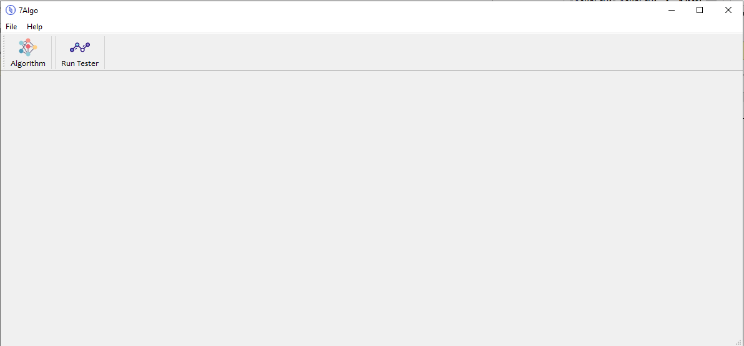

* When you press on “Algorithm “program start automatic trading. That is all very simple.

### **1.5. Run Tester**

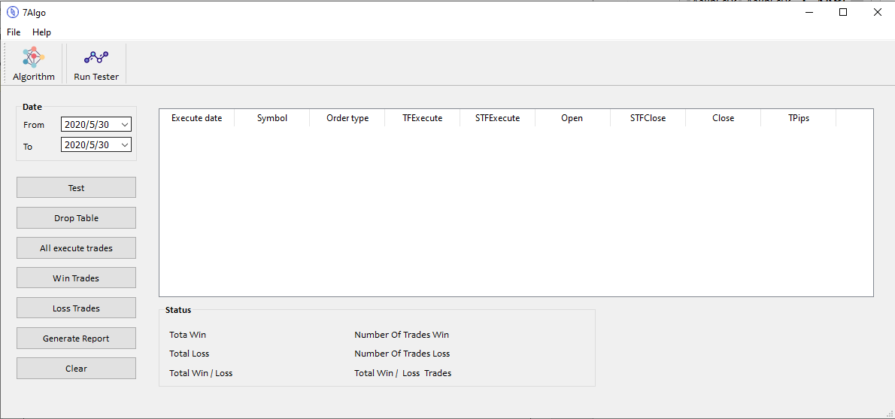

* When you click on “Run Tester” it will display above window, this window contains all the functions to deal with previous data. It tests the current running “Algorithm” with previous data.
* First you need to sleet dates range, “From” is the starting date “To” is the ending date.
* Before you press test button you need to press “Drop Table” button. it will remove all unnecessary data in database.
* Then press on “Test” button, if the dates range is huge this will take some time. (time depend on your computer performance.)
* Then press “All execute trades”. Now you will see all the execute trades display in right side table and under the table Status will displaying like below image.

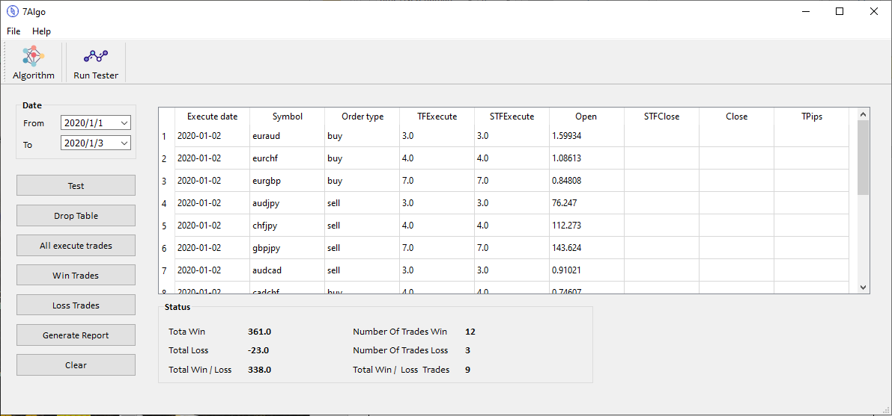

* When you press “Win Trades” you will see all the winning trades in the table.

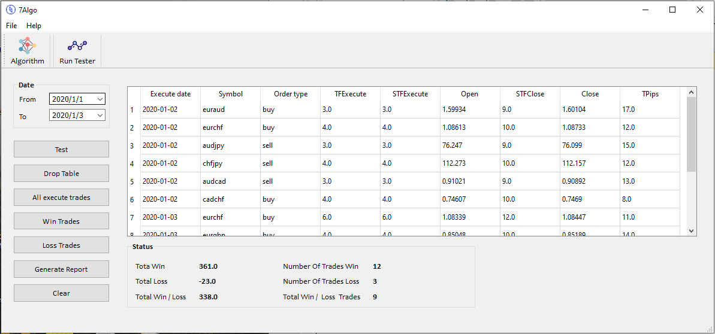

* When you press “Loss Trades” you will see all the loss trades in the table.

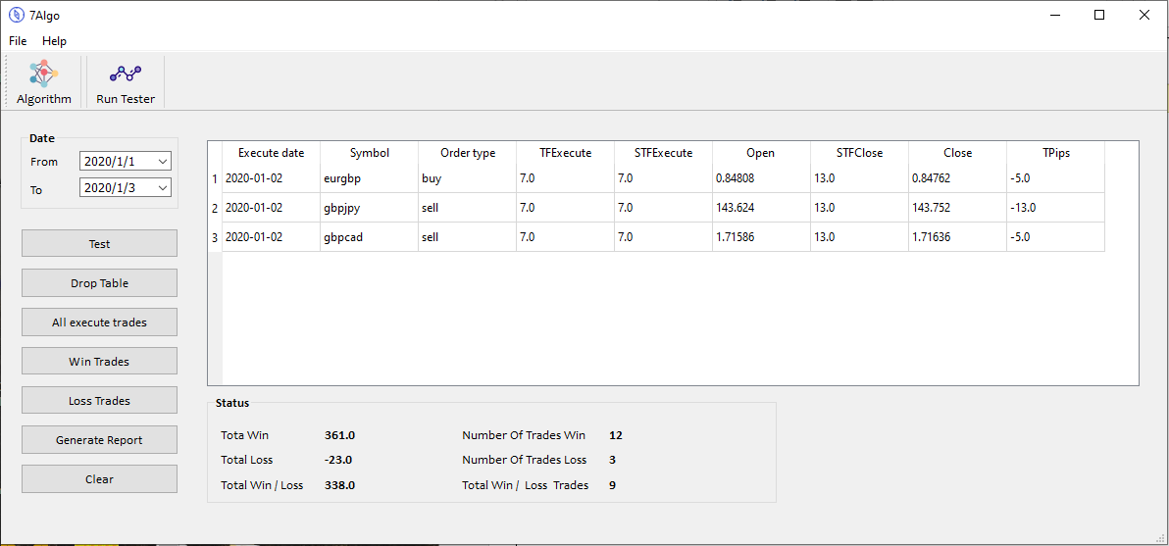

* When you press “Generate Report” button, I will create pdf report with necessary data.

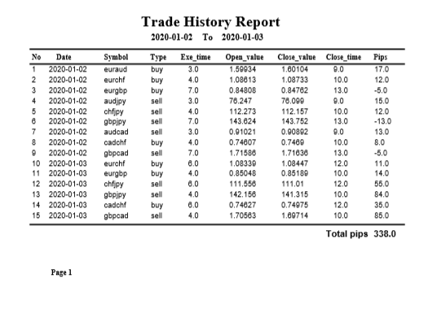

* When you press “Clear” button it will clear all data on table.